Transference - List of Works

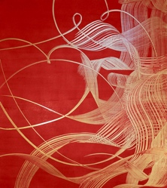
- Gusto (2015), Acrylic on Wooden Panel, 1100 x 960mm $5000

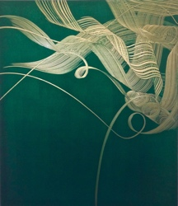
- Avid (2015), Acrylic on Wooden Panel, 1100 x 960mm $5000

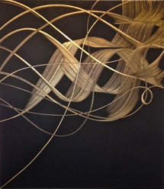
- Flux (2015), Acrylic on Wooden Panel, 1100 x 960mm $5000

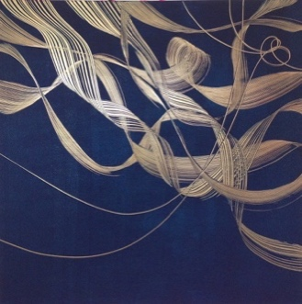
- Poem (2016), Acrylic on Wooden Panel, 1200 x 1200mm $5000

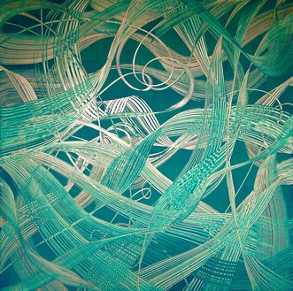
- The Hunt (2016), Acrylic on Wooden Panel, 1200 x 1200mm $5000

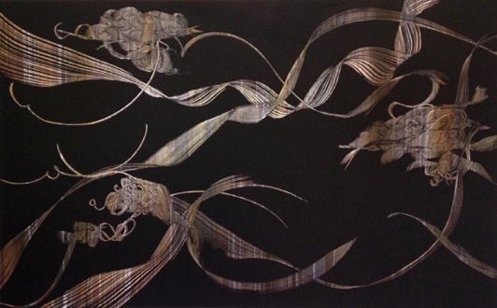
- Sensorium (2016), Acrylic on Wooden Panel, 1920 x 1200mm $7000

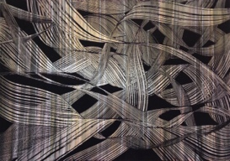
- Inhabit (2016), Acrylic on Wooden Panel, 1200 x 850mm $3000

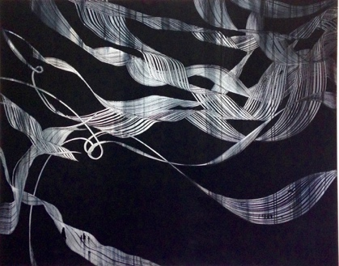
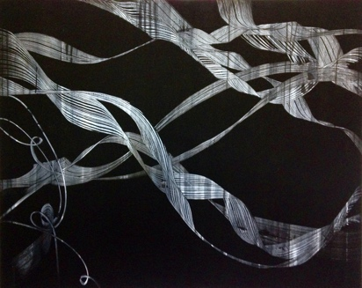
- Wayfarer (Diptych), Acrylic on Wooden Panel, 1500 x 1200mm x 2 $8000

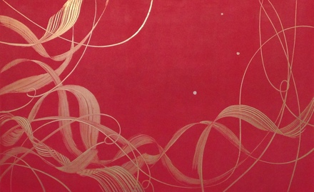
- Well Being (2016), Acrylic on Wooden Panel, 1000 x 1600mm $5000

Lorraine Rastorfer has pioneered a style and way of working that is unique.
Her works begin with fluid gesture and viscous movement, before undergoing constant transformation with light refraction and reflection as the viewer contemplates, watches and moves about.
Patterns are developed, rhythms built, lines curve, twist and turn. Each work has a different melodic structure that slowly emerges and builds in intensity.
Suggesting woven strands and bands of flax fibre or cloth flying, mysterious moments seem to lie at the heart of these paintings. It is like witnessing something private, privileged and utterly secretive. Gold emerges like a calligraphic illumination and an ever-altering interactive process begins.
The paintings are thus in a constant state of flux, substance is shown to be mutable, light engages, changes and alters what is seen and how it is seen.
Moments of visual magic and wonder become actual events, and therefore a collusive process develops between the viewer’s eyes and the ever-changing impacts of light.

Stephen Higginson
Director
Milford Galleries
Dunedin

